1. 
2. **Agenda**:
   1. We will write Unit Test for Save Employee operation.
3. Let’s create package structure for test components.
4. A screenshot of a computer

   Description automatically generated with medium confidence
5. Let’s write the Junit for Repository Components.  
   A picture containing text, screenshot, software, font

   Description automatically generated  
   This annotation loads only repository layer components.  
   This annotation will automatically configure H2 DB and for the same we have included the same dependency too.  
   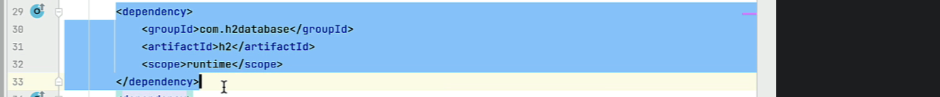
6. We will use this template for writing Junit Test Methods.  
   **Jatin**: This was taken from the next lecture.  
   A blue rectangle with red text

   Description automatically generated with low confidence
7. Let’s write Junit Test Method for “save employee”
8. 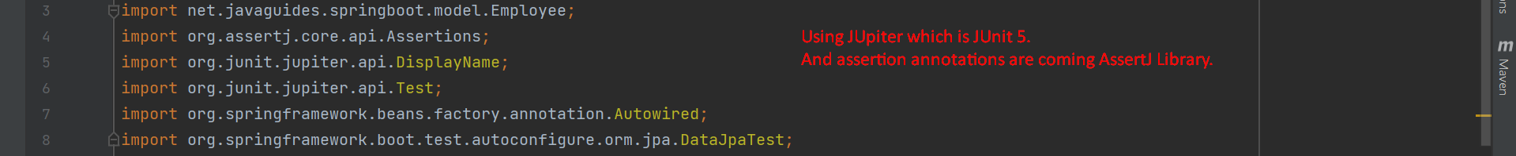  
   A screenshot of a computer

   Description automatically generated with medium confidence
9. A screenshot of a computer

   Description automatically generated
10. A screenshot of a computer

    Description automatically generated with medium confidence